Last Updated: 3/31/2021
Salary Control is the first step in the annual Compensation Planning process. In this step, budget is allocated for the purposes of granting employee merit increases, and this budget is strategically distributed from the Executive Reviewer - President’s Office, via the Executive Reviewer – DFA, eventually down to each Compensation Manager. Once budget has been distributed to each Compensation Manager, they can begin assigning merit and equity increases to their employees.
This QRG outlines the steps of the salary control process and is included in the Annual Merit Allocation Business Process. At this point, the salary policy has been assigned and the compensation plan has been set up in the system by the Compensation Administrator. Budget for merit increases is ready to be distributed to the segment division level.
Contents (Quick Links)
Access SuccessFactors; Access Compensation Salary Control 1
Access Budget Assignment Page 2
Budget Assignment Page Tour 3
Assigning Salary Control – No Holdback 3
Assigning Salary Control – With Holdback 4
Processing Salary Control Without Cascading 5

Access SuccessFactors; Access Compensation Salary Control
- Via the OneCampus portal (one.purdue.edu), select Employee Launchpad
- Log in using Purdue Career Account ID and Password.
- From the Home menu, choose the Compensation module | 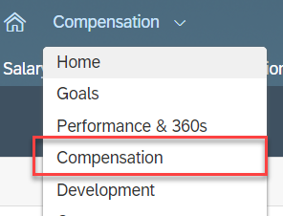

Access Budget Assignment Page
Click the Salary Control tab  Choose the desired Merit Plan | 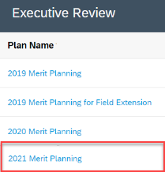
- Select the highest level Compensation Manager for which budget is to be allocated.  - Executive Reviewer – President’s Office: Search for the President  - Executive Reviewer – DFA: Search by Last Name, if applicable  - Click the Change User icon to locate the highest level Compensation Manager for which budget is to be allocated.  - Enter the individual’s name  - Click Search | 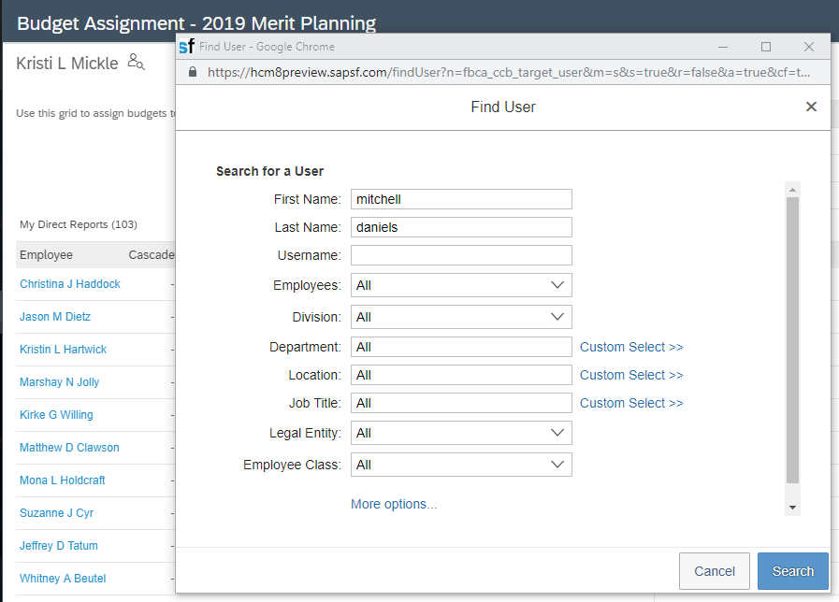
Mark the radio button next to the appropriate user  Click Select User | 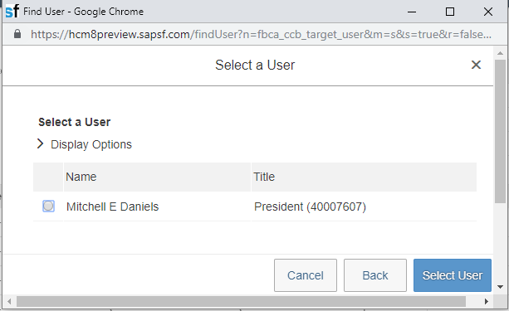
The User’s Budget Assignment page is displayed. | 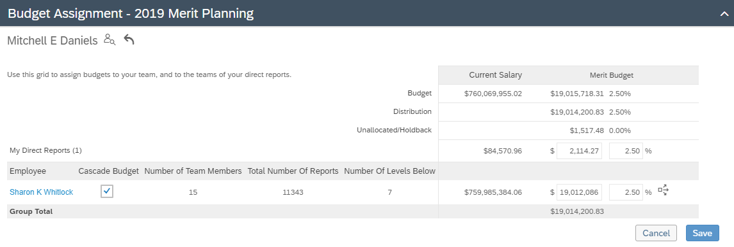

Budget Assignment Page Tour
3
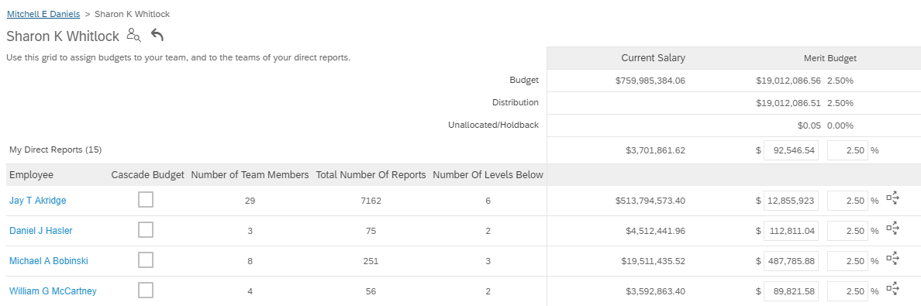
4
2
1
1 | The user’s direct reports and details regarding number of reports and levels in their organization are displayed.  “Direct Report” refers to the reporting structure used for Compensation purposes (i.e. Compensation Managers)
2 | The user’s starting budget and salary policy are displayed (the amount cascaded from Compensation Administration or the Executive Reviewer – President’s Office, if complete and applicable).
3 | The breadcrumbs reflect the number of levels below the president
4 | If budget has already been allocated from a higher level, each Compensation Manager will be allocated that percentage. If the field reads 0%, budget has not yet been allocated.

Assigning Salary Control – No Holdback
Use these steps to cascade the same budget percentage through all levels in the organization.
It is possible to Cascade down through some individuals listed and use the holdback process for others.
Cascading by the Executive Reviewer – President’s Office does not preclude Executive Reviewers from holding back at the Division or Department level.
If holdback is needed, see the Assigning Salary Control – With Holdback section of this document.
Enter/edit the percentage to be cascaded to all levels below the Employee.
For each individual listed for which the budget percentage should be cascaded:  - Ensure that the Cascade Budget checkbox is marked (this is required)  - Click the Cascade button () to distribute the salary control policy to all levels below the Employee.  Notes for Executive Reviewer – DFA:  - If the allocation was not changed from the allocation by the Executive Reviewer – President’s Office, cascading is not required.  - Direct Reports with only one (1) level below will not have or require cascade functionality. | 2  1
Click Save | 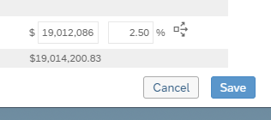
Budget for merit increases has now been cascaded through the Compensation Manager hierarchy below each individual for whom the steps above have been completed.

Assigning Salary Control – With Holdback
Use these steps to assign a specific budget percentage (different than the standard salary policy) to Compensation Manager hierarchies.
The percentage can be cascaded - cascading does not preclude Executive Reviewers from holding back further at the Division or Department level.
Enter the percentage to be assigned to each Compensation Manager | 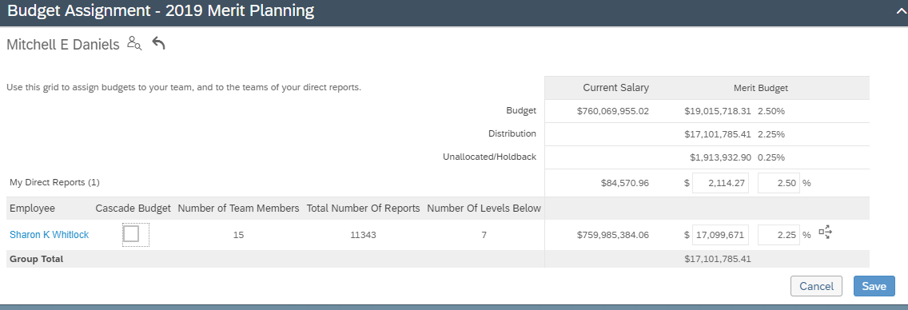
If you do not wish to cascade this percentage to the Compensation Manager hierarchy below the individual, click Save.  To cascade the percentage:  - Ensure that the Cascade Budget checkbox is marked (this is required)  - Click the Cascade button () to distribute the salary control policy to all levels below the Employee. | 2  1
Budget for merit increases, with holdback has now been saved for the Compensation Manager selected and/or cascaded through the Compensation Manager hierarchy below each individual for whom the steps above have been completed.

Processing Salary Control Without Cascading
If the cascade functionality is not used, the Salary Control steps must be completed at each level for each Compensation Manager.
Note: The Cascade feature may be utilized at any point. See Assigning Salary Control – No Holdback for instructions.
- Enter the percentage to be assigned to each Compensation Manager listed  - Click Save  Salary control at this level is complete.  - Click the first employee listed to complete salary control at the next level. | 2  1  3
The next level of Compensation Managers are displayed.  - Enter the percentages to be assigned for each Compensation Manager  - Click Save  - Click the first employee listed to complete salary control at the next level below the Compensation Manager. | 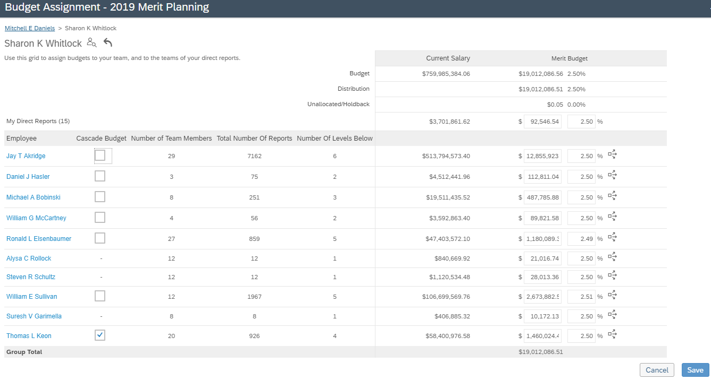  2  After completing Step 3, return to this view and select the second employee, etc. This continues until either the cascade function is used or all Compensation Managers at all levels have been allocated budget.  1  3

